- Overview

This function allows the administrator to modify buyer-initiated RTVs. The data is stored within the tables rtv_header and rtv_item.

- Login Process

The login process should be the same as for User Administration.

- The “BI RTV Admin” Window

After the supervisor successfully logs in, the program should display the “BI RTV Admin” Window. This contains a list of all the applicable Buyer Initiated (BI) RTVs.

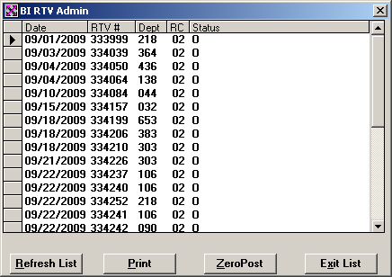

  - Database Details

select
h.rtv_date_entered,
h.rtv_number,
h.rtv_dept,
h.rtv_reason_code,
h.rtv_status,
sum(d.rtv_qty) dtl_sum (not displayed)
from rtv_header h, rtv_item d
where h.rtv_number = d.rtv_number
and rtv_status in (“C”, “I”, “O”, “S”, “Z”)
and rtv_type = “B”
order by rtv_date_entered, rtv_number;

  - Buttons on “SI RTV” Window

The Buttons “Refresh List” and “Exit List” should always remain active. However, the “Print” and “ZeroPost/Suspend/Reopen” button will vary depending on the status of the currently highlighted RTV.

Print Button

- If the status of the selected RTV is “I” (In Process), “O” (Open), or “Z” (System Suspended)”, the button should be disabled.
- Otherwise it should be enabled.

ZeroPost/Suspend Button

- If the status of the selected RTV is “O” (Open), the button should be active and say “ZeroPost”.
- If the status is ‘C” (Closed) and the “dtl_rtv” field equals zero, the button should be active and say “Reopen”.
- If the status is ‘C” (Closed) and the “dtl_rtv” field does not equal zero, the button should be active and say “Suspend”.
- Otherwise the button should be disabled and say “ZeroPost”.

- The “Refresh List” Button

When the user presses the “Refresh List” button, the program should redraw the BI RTV window with the current data.

- The “Print” Button

If the user presses the “Print” button, the program should launch the Vendor Detail Report the currently selected RTV. (See report design document for details.)

- The “ZeroPost” Button

If the user clicks this button, the program should prompt “Zero-Post RTV nnnnnn?’ If the user confirms, the program should change the status to “C”. After the update, the program should refresh the window and highlight the row just updated.

  - Database Details

update rtv_header set
rtv_status = “C”,
rtv_status_date = TODAY
where rtv_number = <current RTV #>;

- The “Suspend” Button

If the user clicks this button, the program should prompt “Suspend RTV nnnnnn?’ If the user confirms, the program should change the status to “S”. After the update, the program should refresh the window and highlight the row just updated.

  - Database Details

update rtv_header set
rtv_status = “S”,
rtv_status_date = TODAY
where rtv_number = <current RTV #>;

- The “Reopen” Button

If the user clicks this button, the program should prompt “Reopen RTV nnnnnn?’ If the user confirms, the program should change the status to “O”. After the update, the program should refresh the window and highlight the row just updated.

  - Database Details

update rtv_header set
rtv_status = “O”,
rtv_status_date = TODAY
where rtv_number = <current RTV #>;

- Double-Clicking on an RTV Header Record

Double-clicking a header row will cause the program to open a new window listing the detail records associated with the RTV record.

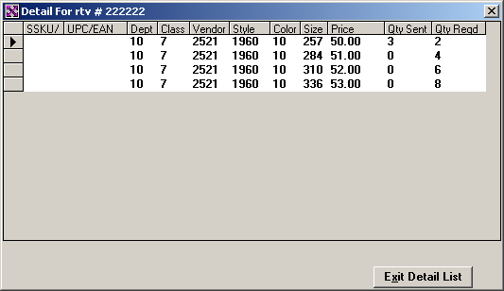

  - Database Details

select
rtv_dept,
rtv_class,
rtv_vendor,
rtv_style,
rtv_color,
rtv_size
rtv_orig_retail,
rtv_qty,
rtv_expected_qty
from rtv_item
where rtv_number = <selected RTV number>
order by rtv_dept, rtv_class, rtv_vendor, rtv_style, rtv_color, rtv_size,
rtv_orig_retail;

  - Double-Clicking on an RTV Detail Record

Double-clicking a detail row will cause the program to open a new window where the user is able to modify the quantity sent.

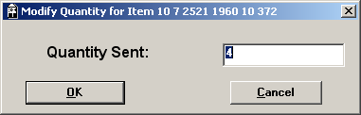

The new value for the field should be within the range 0 <= new-value <= 9999. After the database update, the program should close the “update” window and return to the listing of detail records. The row just updated should be highlighted.

    - Database Details

update rtv_item set
rtv_qty = <new value>
where rtv_number = <RTV header value>
and rtv_dept = <RTV department>
and rtv_class = <RTV class>
and rtv_vendor = <RTV vendor>
and rtv_style = <RTV style>
and rtv_color = <RTV color>
and rtv_size = <RTV size>
and rtv_orig_retail = <RTV original retail>;

